Temasek Polytechnic

School of Informatics and IT

**Diploma in Information Technology (IT)**

Software Requirement Specifications (SRS)

**Project Particulars**

|  |  |
| --- | --- |
| **Tutor** | Miss Ho Li Chin |
| **Class** | P01 |
| **Project Title** | Delonix Regia Hotel Management System |

**Project Team’s Particulars**

|  |  |
| --- | --- |
| **Matric Number** | **Student Name** |
| 1405307H | Celine Neo Shi Ling |
| 14012529A | Chen Yee Yin (Andrea) |
| 1406183B | Ong Jing Hui Rachael |
| 1402047C | Serena See Lee Ping |

Contents

**1** **DISTRUBUTION OF WORKLOAD** 3

**2** **OVERVIEW OF REQUIREMENTS** 4

*2.1 System Functions 4*

*2.2 User Characteristic 5*

*2.3 General Constraints 5*

*2.4 Functional Requirements 6*

*2.5 Data Requirements 10*

*2.6 User Interface Requirements 12*

*2.7 Interface with Other System 14*

*2.8 Assumptions 15*

**3** **OPERATIONAL AND QUALITY REQUIREMENTS** 16

*3.1 Operating Enviroment 16*

*3.2 Development Constraints 16*

*3.3 Performance 17*

*3.4 Availability 18*

*3.5 Security and Access Control Requirements 18*

**4** **REFERENCES** 20

# **DISTRUBUTION OF WORKLOAD**

|  |  |  |  |
| --- | --- | --- | --- |
| **Parts of SRS** | **Member 1** | **Member 2 (If)** | **Member 3 (If)** |
| ***Overview of Requirements*** | | | |
| System Function | Rachael | Serena |  |
| User Characteristics | Rachael |  |  |
| General Constraints | Serena |  |  |
| Functional Requirements | Andrea | Rachael | Serena |
| Data Requirements | Andrea | Rachael |  |
| User Interface Requirements | Andrea |  |  |
| Interface with Other Systems | Andrea |  |  |
| Assumptions | Andrea | Serena |  |
| ***Operational and Quality Requirements*** | | | |
| Operating Environment | Celine |  |  |
| Development Constraints | Serena |  |  |
| Performance | Rachael |  |  |
| Availability | Rachael |  |  |
| Security and Access Control Requirements | Andrea |  |  |

|  |  |
| --- | --- |
| **Requirement Gathering** | **Members** |
| Room Availability & Booking Module | Celine, Rachael |
| Housekeeping & Staff Management Module | Serena |
| Reporting Module & User Management | Andrea |

# **OVERVIEW OF REQUIREMENTS**

## **SYSTEM FUNCTIONS**

This system is designed for Delonix Regia Hotel, run by Mr. and Mrs. Wang. This system aims to help them manage their hotel more efficiently in order to bring in more business for Delonix Regia Hotel. The system is broken down into four sub modules in order to simplify the whole process and maximize the usage of the system. They are arranged accordingly as per Mr. Wang’s request. System functions include:

1. **Room Availability and Booking Module**

This module checks for available room and makes booking or reservations. It also handles check-in and check-out for guest. This module also comprises of a sub Payment module.

1. **Housekeeping and Staff Management Module**

This module handles housekeeping information, if a room needed to be cleaned or is scheduled for cleaning. It also holds the staff information and states which of the 4 duties does the staff belongs to (General Maintenance, Room Maintenance, Estate Maintenance and Security).

1. **Reporting Module**

This module handles the generation of 5 different kinds of reports

* Room status

Lists all the room in the hotel if they are vacant, occupied or vacant but scheduled for cleaning.

* List guest in a room

Lists all guests that are staying in a particular room.

* List all guest in all rooms

Lists all the guests that are currently staying or had stayed at the hotel on a specific date.

* Room occupancy

Lists the statistics on the room occupancy, generated on a daily, weekly, monthly and yearly basis. Available to only Management and Administrator.

* Housekeeping

List duties that the staff are allocated to, generated on a daily, weekly, monthly and yearly basis. Available to only Management and Administrator.

1. **User Management**

This module handles the creating, updating, editing and deleting of an account. This module is only available to the administrator, which is Mr. Wang.

## **USER CHARACTERISTIC**

There are 3 main users of the system:

1. **End user**

The end user refers to the one front desk staff who are doing the booking and reservation of the rooms. They are the lowest in the level of hierarchy, thus they only have access to the Booking and Room Availability module and certain parts of the Reporting module.

1. **Management Staff**

The management staff refers to the middle tier of the hierarchy. They are the managers and supervisors of the hotel management system. These staff will be able to access all modules except the User Management module.

1. **Administrator**

The administrator is the highest level of the hierarchy, thus having access to all four of the modules. There is only one administrator, which is Mr. Wang.

## **GENERAL CONSTRAINTS**

These are a few general constraints to take note while developing the system:

1. **Dependency**
   * There is no dependency on any other systems. This is stated during the interview with Mr. Wang. Therefore, there is no need for any integration with any existing software of system.
2. **Existing Hardware or Software**

* There is no existing hardware or software used. This is stated during the interview with Mr. Wang.

1. **The system will be run under Windows 7**
   * After comparing Windows 7 to Windows 8.1, the team has decided that Windows 7 will be a better choice. The classic, familiar desktop is a popular choice amongst businesses. Although Windows 8.1 has more enterprise features, Windows 7 has the benefit of it being tested and tried. Stability is essential. Users have complaint about Windows 8.1 breaking down and simple things like the ability to print have encountered problems. Besides, as the system is a web-based system, there isn’t much needs for many enterprises services. Thus, the team decides that Windows 7 is a much more suitable OS to be running on.
2. **The system is web-based**
   * As the system is web-based, Mr. Wang’s hotel must be able to connect to the internet and the employees must be well versed in using a web-based system.
3. **Maintainable**
   * The code needs to be highly maintainable, as software engineering and design methodology is constantly evolving. If this software is to be maintained in a time and cost effective manner, the code needs to be highly maintainable.
   * The system must not crash as it is only functioning on one computer.

## **FUNCTIONAL REQUIREMENTS**

This section is organized by the modules and the features encapsulated in the Delonix Regia Hotel Management System. First, the four modules are described: Room Availability and Booking Module, Housekeeping and Staff Management, Report Management and User Management. These are linked to how the system works.

1. **Room Availability and Booking Module**

This feature enables users to check if the room is available for booking and also does the reservation for the room. It comprises of booking a room for the guests, check in and check out of guests, cancelling of room and payment while check out. Staff will be able to edit the records under this module. They will be able to create, retrieve and update this module.

*Room Availability*

The staff will generate a report of the room status to check if the type of room that the guest wish to stay in is available (refer to Report Management)

|  |  |
| --- | --- |
|  | **CHECK IN** |
| The staff will be able to help the customer to reserve rooms of their choice and check in with: | * + Guest ID   + Check-In ID   + Check-In Time   + Desired Check-Out Time   + Room ID   + Number of Guest     - Number of children     - Number of adults   + Additional Remark     - Type of bed (Queen / King / Single Bed)     - With or without balcony     - Smoking or non-smoking room     - Any late check-out |

|  |  |
| --- | --- |
|  | **CHECK OUT** |
| The staff will be able to help the customer to check out of their choice with: | * + Guest ID   + Check-In ID   + Check-Out Time   + Room ID   + Bill ID   + Housekeeping |

|  |  |
| --- | --- |
|  | **BILL** |
| The bill will include: | * + Bill ID   + Room Rates   + Date Stayed   + Number of Days   + Additional Cost     - Missing items from the rooms     - Spoilt items from the room     - Mini Bar       * Mini Bar ID   + Payment Amount   + Payment Mode     - Credit Card / Nets / Cash   + Card Details     - Card ID   + Bill Status     - Paid or unpaid |

1. **Housekeeping and Staff Management Module**

This feature enables the administrator and the management of the hotel to view the employee table and also the type of duty that each of the staff is assigned to.

|  |  |
| --- | --- |
|  | **STAFF** |
| This table holds all of the staff information, which is only available to the administrator and the management level. | * + Staff ID   + First Name   + Last Name   + Date of Birth   + Bank Account   + Country   + City   + Address   + Postal Code   + Phone Number   + Duty Type |

1. **Report Module**

There are different access permissions for the Reporting Module, so as to retain data integrity. With that in mind, the reports retrieved from this module will mostly be static (read-only formats) as it will only be for the staff’s reference. Guest information can be retrieved by a guest ID, which is efficient as every ID is unique. However, there will be one report which allows alterations, which is the Hotel Guests report. The receptionist, who has control over the guests’ information, will be able to make any necessary changes or amendments to the guests’ details. Examples of a scenario where such changes are required is if there is a returning guest of Delonix Regia Hotel, and he or she has changed to a mobile number, which is no longer the same as the one previously recorded in the system.

*Operations available for this module: Retrieve and Update*

1. **User Management**

The user management module will solely and strictly only be accessed by the administrator, who happens to be Mr. Wang. This is to ensure that any changes made to the user accounts of the system will have to pass through Mr. Wang before it is officially made. Mr. Wang holds the authority of adding, removing or making changes to the user accounts of the system. He has the visibility of all the user accounts in the system (Eg. Username, staff ID, access level). In circumstances where a user forgets his or her account password and with the consent of Mr. Wang, it is able to be reset by the system.

*Operations available for this module: Create, Retrieve, Update and Delete*

## **DATA REQUIREMENTS**

[Data types of each table]

|  |  |
| --- | --- |
| **GUEST** | |
| **Attributes** | **Datatype** |
| guestId | Int |
| checkInId | Int |
| firstName | String |
| lastName | String |
| email | String |
| address | String |
| city | String |
| country | String |
| postalCode | Int |
| phoneNo | Int |

|  |  |
| --- | --- |
| **CREDIT** | |
| **Attributes** | **Datatype** |
| creditCardNo | Int |
| expirationDate | Int |
| holderName | String |

|  |  |
| --- | --- |
| **CHECK IN** | |
| **Attributes** | **Datatype** |
| checkInId | Int |
| guestId | Int |
| paymentMode | String |
| checkInDateTime | String |
| desiredCheckOutDateTime | String |
| roomId | Int |

|  |  |
| --- | --- |
| **CHECK OUT** | |
| **Attributes** | **Datatype** |
| checkOutId | Int |
| checkInId | Int |
| checkOutDateTime | String |
| paymentMode | String |
| creditCardNo | Int |
| cardType | String |
| billId | Int |

|  |  |
| --- | --- |
| **BILL** | |
| **Attributes** | **Datatype** |
| billId | Int |
| dateStayed | Int |
| miniBarId | Int |
| roomId | Int |

|  |  |
| --- | --- |
| **MINI BAR** | |
| **Attributes** | **Datatype** |
| miniBarId | Int |
| miniBarItem | String |
| itemCost | Decimal |

|  |  |
| --- | --- |
| **STAFF** | |
| **Attributes** | **Datatype** |
| staffId | Int |
| staffName | String |
| dob | Int |
| bankAcc | Int |
| address | String |
| city | String |
| country | String |
| postalCode | Int |
| phoneNo | Int |
| dutyType | String |

|  |  |
| --- | --- |
| **ACCOUNT** | |
| **Attributes** | **Datatype** |
| username | String |
| password | String |
| staffId | Int |
| accessLevel | String |

|  |  |
| --- | --- |
| **ROOM** | |
| **Attributes** | **Datatype** |
| roomId | Int |
| roomType | String |
| roomRate | Decimal |
| status | String |
| isSmoking | String |

## **USER INTERFACE REQUIREMENTS**

* **Welcome Page**

This is the first thing seen by the user who logs onto the system. From the screen shot below, (1) indicates the user’s Staff Code, which is unique to every Employee working at Delonix Regia Hotel.

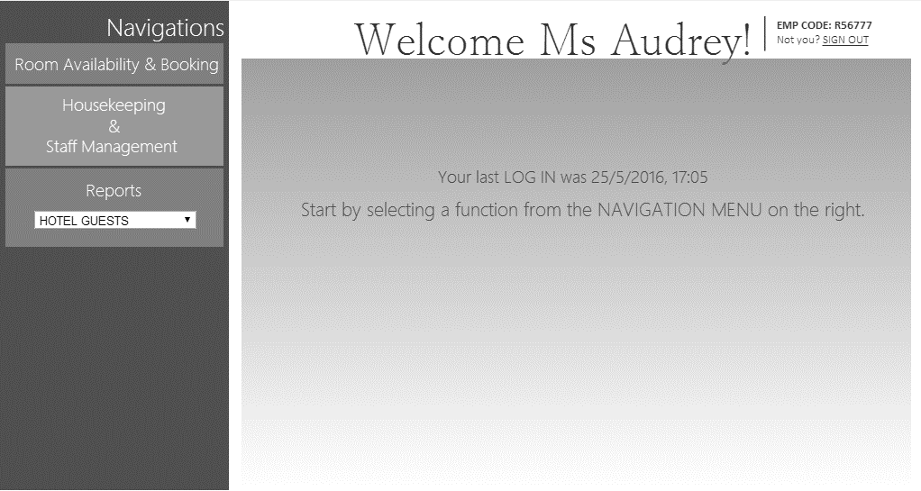

* **Function**

The example of one function that is showed in this screen shot is the Booking module, which can be accessed by navigating *Room Availability & Booking > Booking Module (New Booking) > Booking Module* from the navigation menu on the left. After which, the below screenshot will be what the user sees. There are **two main sections** to this module, one being “GUEST DETAILS” and “BOOKING DETAILS”. The next thing to note is the **asterisk indicated beside some fields** (Example FIRST NAME, LAST NAME, NRIC, etc), this means that the particular field is mandatory, and cannot be left empty.

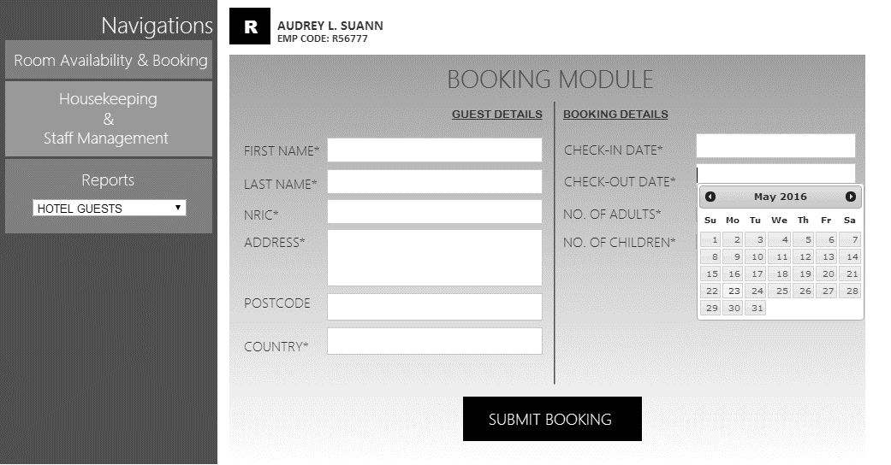

The Reports navigation is a drop down list where the user can select which report he/she wants to view.

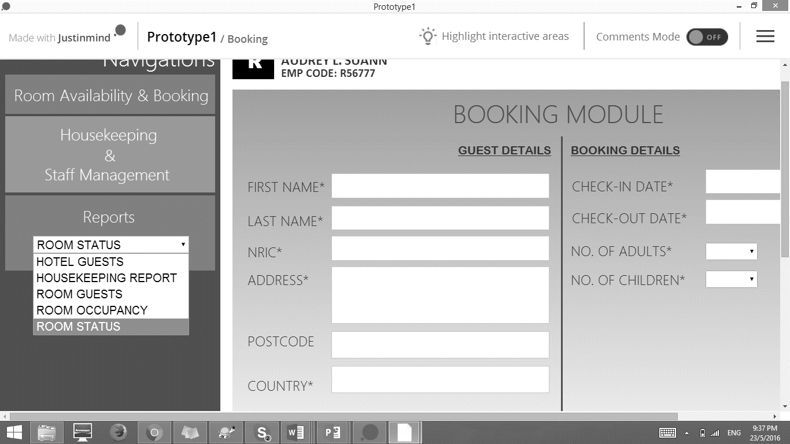

* **Error Message**

This is one type of error message which a user will come across using this system. In this case, let us assume that Receptionist has tried to access the Room Occupancy page, which is supposedly a page that a Receptionist does not have permission to view. What happens then? He or she will be directed to the page below.

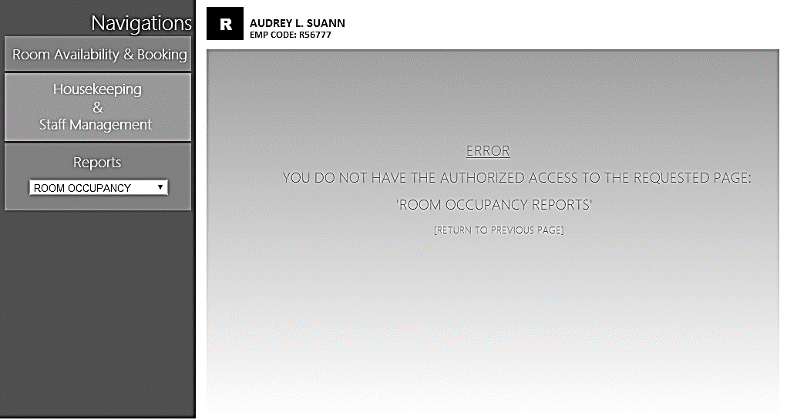

You can see that the last line of the error message says “RETURN TO PREVIOUS PAGE”, so it ensures that users are able to return to where they were originally at, instead of having to try navigating to where they originally were.

## **INTERFACE WITH OTHER SYSTEM**

**Peripheral Hardware**

In this case, we will be looking at one specific type, being the printer. This hardware is relevant in this context as hardcopy information will be needed from time to time (Eg. Payment receipts). Tasks must be sent to the printer before the documents can get printed. For this to happen, the printer has to be configured to the network that the system’s interface is on.

*Security Requirements*

Unless the printer administrator reconfigures the printer, it will be susceptible to remote intruders where they are able to get full access to the data that is being sent to the printer. Therefore, it is vital that a hardware device like this complies with the following:

* *Application of Manufacturer Firmware*

It is necessary to review the manufacturer recommendations when it comes to secure printer configuration. There are usually manufacturer firmware updates which should be executed to achieve the goal of device security. Any other necessary configuration changes should be made as well; this includes the access control or a firewall.

* *Campus-only Computer Address*

To ensure that the printer is not available to the general internet, it is highly recommended to use campus-only computer addresses (IP addresses with 10.135.x.y), instead of public internet computer address (IP 128.135.x.y). Secure Socket Layer should also be enabled for encrypted network transport using https.

* *Passwords*

In the case where there is an absolute need of remote devices to be connected to the printer, the strength of a password is extremely important. A strong password would be one which includes numbers, symbols, capital letters and lower case letters.

* *Restrict Access*

Unused remote access services (Eg. SNMP, FTP) and protocols (AppleTalk) should be disabled to avoid third party intrusion.

## **ASSUMPTIONS**

It is assumed that the hotel is a small hotel, with not more than 5 level high, and each level, there is only a maximum of 3 rooms. It is assumed this way as there is only one computer at the reception count to manage the whole hotel system. Thus, if the hotel is too big for only one computer to process all these guests’ requests at the same time, it will either crash or lag very badly. Thus, the team have assumed it to be a small sized hotel where only 1 computer is able to manage all the requests.

# **OPERATIONAL AND QUALITY REQUIREMENTS**

## **OPERATING ENVIROMENT**

Single computer at reception staff area.

Lenovo S500z AIO desktop running windows 7 professional 64

Intel Core i7-6500U Processor

8.0GB (DDR4) RAM

1TB HDD

Connect via Wi-Fi

Application will be launched via Web Client.

## **DEVELOPMENT CONSTRAINTS**

1. **Time Frame**
   * The whole project is only given 8 weeks to be developed. As we had planned for it to be done in 7 weeks, we have allocated our timing as followed:
     + - (1 week) Planning
       - (1 week) Design
       - (3 week) Implementation
       - (1 week) Testing
       - (1 week) Deployment
   * Therefore, the implementation must be done within 3 weeks
2. **Resources**
   * Manpower
     + - There’s only 4 people working on the project. Each person has a different schedule, thus it makes it hard to come together to produce a system
   * Budget: $70,000
3. **Others**
   * Coding
     + - There might be complications while coding
   * Payment Module
     + - It must be ensured that the payment module will not crash when there are a lot of processing done at the same time.

## **PERFORMANCE**

For room availability and booking module, the check-in, checking of room status report should be within 2 seconds, so that guests are able to make informed decision and reserve the room while they fill in their details for checking in, and the process after the customer has provided all the details should be within 3 seconds as customer would not like to wait a long time to check-in to the hotel, and there might be clashes if the room booking takes too long. For Check-out, it should be processed within 2 seconds as it is peak period where most guests would want to check out. The peak period timing is from 11am to 12pm daily.

For housekeeping and staff management module, where staff would need to check their duty and management level to assign duty to staff, the system response time should be within 3 seconds to retrieve the data and display, this is to assure that staff and management level do not need to take a long time to check their duty or assign duty to staff.

For reporting module, system needs to extract data from different place and present onto the screen, so allowed response time would be 5 seconds, as it is not much of a hurry, the response time allowed can be slower.

For user management module, allowed response time for system would be within 3 seconds, as staff might need the information to do their work.

## **AVAILABILITY**

It is where the system should be available and running, and only down time for system would be during major renovations where there would not be any working staff and guest to check in.

System availability is as follows:

* System is required to run 24 by 7
* Backup is on every first Sunday of the month 2-3am
* If maintenance is needed, it should be completed within one hour from 2-3am

## **SECURITY AND ACCESS CONTROL REQUIREMENTS**

|  |  |  |  |
| --- | --- | --- | --- |
|  | **Role** | | |
| *End User (Receptionist)* | *Staff Management* | *Administrator* |
| *User Access* | Data   * Customer Details * Reservation Details * Room Details * Payment Details   Functions   * Room Availability Module (ALL*) * Booking Module (ALL) * Reports (Room Status ONLY) | Data   * Report Information   Functions   * Staff Management (ALL) | Data   * Customer Details * Room Details * Reservation Details * System User Details * Report Information   Functions   * Room Availability and Booking Module * Housekeeping and Staff Management Module * Reporting Module |
| *User Restrictions* | Data   * Report Information:   Room Guests Details, Hotel Guests Details, Room Statistics, Housekeeping Details  Functions   * User Management * Reports:   Room Guests, Hotel Guests, Room Statistics, Housekeeping Report | Data   * Customer Details * Reservation Details * Room Details * Payment Details   Functions   * Booking Module * Room Availability Module * User Management | Data   * NIL   Functions   * NIL |
| *Audit Log* | NIL | NIL | Activity Log  All activity to be recorded in the system, so that there is accountability for each action made. |
| *Security Requirements* | Should customers pay by card, the **credit card number** should be **encrypted**. | **Credentials and password** to be **requested again** to authenticate identity before granting access to pages. | **Credentials and password** to be **requested again** to authenticate identity before granting access to pages. |

*\*\* ALL indicates the four sub-functions: Create, Retrieve, Update and Delete.*

# **REFERENCES**

* *Windows 8.1 vs. Windows 7 – Which is best for you? (n.d.). Retrieved May 20, 2016, from http://www.itpro.co.uk/desktop-software/21919/windows-81-vs-windows-7-which-is-best-for-you/page/0/2*
* *Lenovo B50. (2015). Retrieved May 25, 2016, from http://uk.pcmag.com/lenovo-b50/46302/review/lenovo-b50*